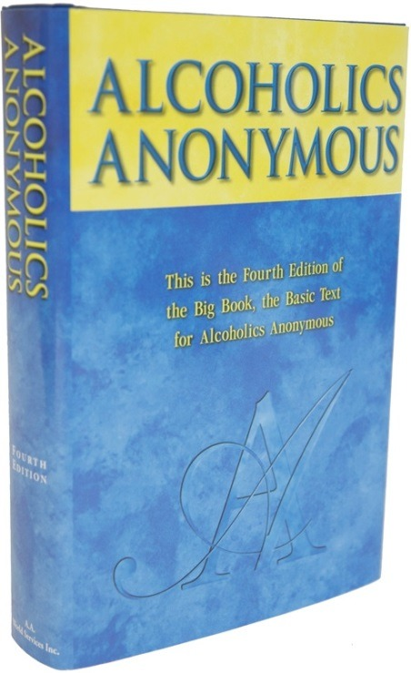
VOLUNTEERS NEEDED:
BIG BOOK CONFERENCE 2023

District 61 is hosting the Big Book Conference
Saturday, November 4th, 2023
Lord of Life Church
40W605 IL-38, Elburn IL

Planning Committee meets
the last Friday of the Month at 6:00 pm
before the District Meeting at
Fox Valley Presbyterian Church
227 East Side Dr., Geneva IL

Volunteers needed:

Accessibilities - Technology - Hospitality - Registration – Grapevine – Program – Public Information

CONTACT: Brett O. – brettolson7@gmail.com

